Practicum No.11 Date:……….
Stepper Motor using simulator

- Practical Significance

Stepper motors are widely used in precise motion control applications such as CNC machines, robotics, 3D printers, surveillance systems, and industrial automation. Interfacing a stepper motor with the AT89C51 microcontroller enables students to understand digital control of electromechanical systems, pulse sequence generation, and current amplification using driver ICs such as the ULN2003.This practicum demonstrates how digital signals from a microcontroller can be translated into controlled rotational motion through proper driving circuits. Students learn the fundamentals of stepper motor operation, excitation modes, torque considerations, and simulation testing using Proteus before hardware implementation. This forms the basis for real-world motion control systems and embedded automation solutions.
- Competency and Industry-Specific Practical Skills

This practicum develops the following competencies aligned with industrial motion-control requirements:
Use the principles of computer architecture to optimize system performance.
a) Select the appropriate microcontroller and driver circuitry based on torque, current, and sequencing requirements (PDO).
b) Implement correct stepper motor excitation sequences (full-step, half-step) using AT89C51 programming (PDO).
c) Use driver ICs safely to protect low-power microcontrollers from overcurrent conditions (PDO).
d) Configure and simulate embedded motion-control systems using Proteus (PDO).
e) Troubleshoot miswiring, incorrect excitation sequences, and timing errors (CDO).
- Relevant CO(s) (As stated in the Course Structure)

CO4: Use interfacing techniques for programmable peripheral devices to enhance input-output operations in computer systems.
(In this experiment, aligned to microcontroller–actuator interfacing fundamentals.)
- Practical Outcome (PrO) (As stated in the Course Structure)

- PrO: Develop a system to display information representation for the given application

- Related ADO(s) (As stated in the Course Structure)

a) Follow safe practices described for electronic laboratories.
b) Handle microcontroller kits and power supplies safely.
c) Function effectively as a team member.
d) Maintain clean wiring arrangements and proper housekeeping.
e) Follow ethical practices in reporting results.
- Minimum Underpinning Theory (Include relevant content & images for this practicum.)

A stepper motor is an electromechanical device that converts electrical pulses into discrete mechanical movements. Each pulse rotates the shaft by a fixed angle known as the step angle. Two key concepts are:

1. Working Principle
A stepper motor consists of multiple electromagnetic coils arranged in phases. When these coils are energized in a defined sequence, they create magnetic fields that move the rotor in steps. Example excitation sequences:
- Full-Step Sequence: 4-step rotation
- Half-Step Sequence: 8-step rotation (smoother motion)

2. Need for Driver IC (ULN2003)
The AT89C51 cannot supply the current needed to energize the motor phases.
The ULN2003 Darlington array:
- Provides up to 500 mA per channel
- Protects the microcontroller
- Allows direct driving of stepper phases

3. Role of Proteus Simulation
Proteus allows:
- Visual verification of step sequence
- Observing stepper direction and speed
- Debugging without damaging hardware

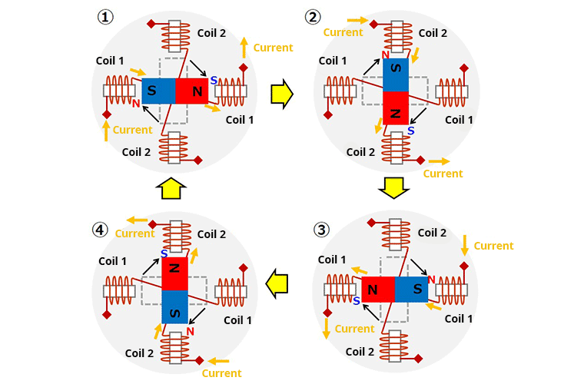
Figure 1 Stepper Motor

- Practicum Set-up/Circuit Diagram/Algorithm/Flowchart (Include probable photos of experimental set-up.)

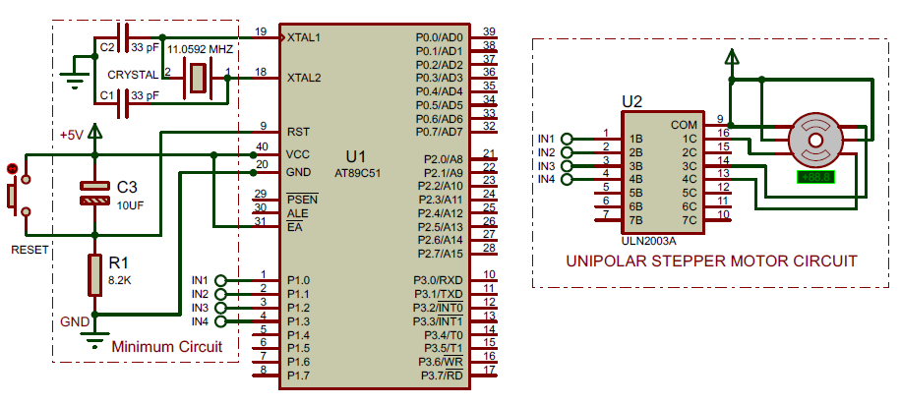

- Matlab Simulation and Output
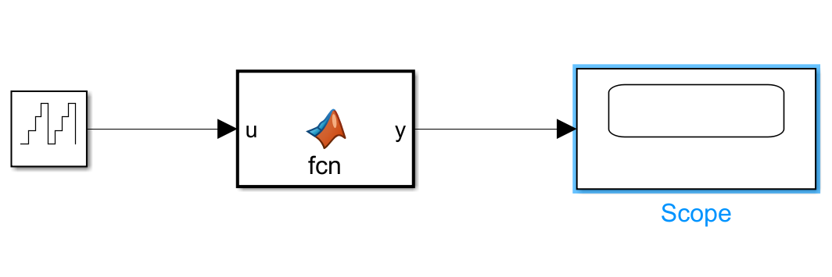
Output:

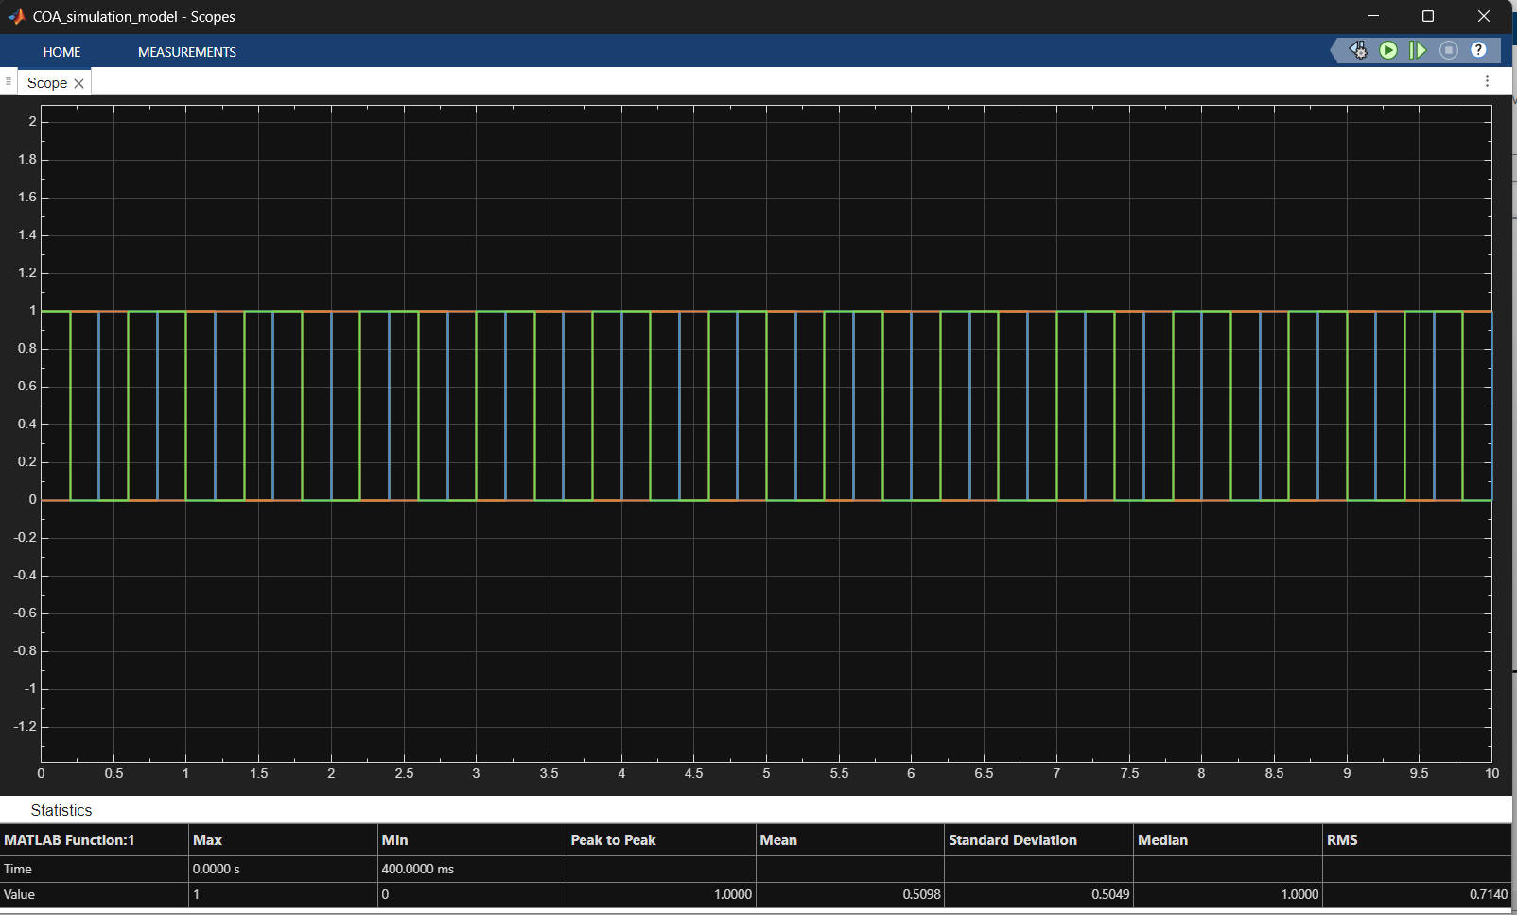
- Resources Required

S.No | Resource | Suggested Broad Specification | Quantity
1 | Microcontroller | AT89C51 DIP-40 | 1
2 | Stepper Motor | 5-wire or 4-phase unipolar stepper (e.g., 28BYJ-48) | 1
3 | Driver IC | ULN2003 Darlington transistor array | 1
4 | Power Supply | 5V or 12V depending on motor rating | 1
5 | Crystal Oscillator | 11.0592 MHz + 33 pF capacitors (2 Nos.) | 1 set
6 | Reset Circuit | Push button, 10 kΩ resistor, 10 µF capacitor | 1 set
7 | Connecting Wires | For Proteus wiring | —
8 | Proteus Software | Simulation of microcontroller and stepper | —
9 | HEX File | Compiled program for sequence control | 1 file
10 | Decoupling Capacitors | 0.1 μF (for MCU stability) | 1–2

- Safety Precautions
a) Ensure correct polarity while connecting power supplies to avoid damaging the microcontroller or motor.
b) Do not directly connect the motor to AT89C51 pins—always use ULN2003.
c) Verify voltage rating of the motor (5V/12V) before powering.
d) Avoid touching energized components in real hardware setups.
e) Keep wiring neat to avoid short circuits during testing.

- Procedure (Self-Instructional)
- Study the circuit diagram showing connections between AT89C51, ULN2003, and the stepper motor.
- Open Proteus and create a new schematic.
- Place the AT89C51, ULN2003, and Stepper Motor from the library.
- Wire the four IN pins of ULN2003 to AT89C51 Port pins (e.g., P2.0–P2.3).
- Connect ULN2003 OUT pins to stepper motor coil wires.
- Provide a separate power supply to the motor (5V or 12V as required).
- Connect oscillator crystal (11.0592 MHz) and capacitors to AT89C51 XTAL1/XTAL2 pins.
- Add reset circuitry to the RST pin.
- Ensure all VCC and GND pins of components are correctly connected.
- Load the HEX file into AT89C51 through Edit Component → Program File.
- Verify pulse sequence in the assembly program (full-step or half-step).
- Start simulation and observe the motor rotating in steps.
- Adjust pulse delay in the program to vary motor speed.
- Modify excitation sequence to reverse motor direction.
- Validate that ULN2003 is correctly driving the motor coils by checking current flow.
- Test different step modes and record observations.
- Stop simulation, correct wiring if the motor vibrates but does not rotate.
- Restart simulation and capture screenshots of successful rotation.
- Experiment with half-step for smooth motion.
- Document motor behaviour for different speeds.
- Save simulation for future reference.
- Record any anomalies such as motor stalling or missteps.
- Validate direction control by modifying the pulse order.
- Compare simulation results with theoretical step angle calculations.
- Adjust delay loops to analyse torque-speed relationship.
- Re-run simulation after minor code modifications.
- Verify that the ULN2003 does not overheat during prolonged runs.
- Test boundary conditions (very small/large delays).
- Complete all required wiring checks to avoid shorts.
- Prepare a detailed report including code, circuit, screenshots, and observations.
- Actual Resources Used

S. No. | Name of Resource | Broad Specifications |  | Quantity | Remarks  (If any)
 |  | Make | Details
 | MATLAB Software | MATLAB | R2025b | 1 | Used for simulation
 | Stepper Motor Concept | - | Full step sequence  Logic | 1 | Theoretical reference
 | MATLAB Plot Tool | Built-in | Polar plotting  (polarplot) | 1 | For visualization

- Actual Procedure Followed

- Opened MATLAB software and created a new script file.
- Defined the full-step sequence for stepper motor operation.
- Initialized variables such as angle and delay time.
- Used nested loops to iterate through step sequences and rotations.
- Incremented the angle by 90° for each step.
- Displayed the step sequence in the command window.
- Used polarplot to visualize the angular movement of the motor.
- Added delay using pause() to simulate motor speed.
- Executed the program and observed the rotational behavior.

- Results/Observations
- The stepper motor simulation successfully showed rotation in discrete 90° steps using the full-step sequence.
- The polar plot visually represented the angular movement, completing multiple rotations as per the loop.
- Interpretation of Results

  - The simulation demonstrates how a stepper motor rotates in fixed angular steps based on input sequences.
  - Each input sequence energizes coils in a specific pattern, producing controlled motion.
  - The 90° increment confirms correct implementation of the full-step mode.
  - The delay parameter directly affects the speed of rotation.

- Conclusions

- The MATLAB simulation effectively models the working of a stepper motor in full-step mode.
- Controlled sequences result in precise angular displacement.
- Visualization using polar plots helps in understanding motor rotation clearly.
- This method can be extended for half-step and micro-stepping techniques for smoother motion.

- Suggested Practicum Related Questions:

Note: Below are a few questions related to industry-specific higher-order thinking skills (HOT) that teachers must use to ensure students achieve the predetermined course outcomes.
- Compare ULN2003-based driving with modern MOSFET-based stepper drivers in terms of torque, efficiency, and control flexibility.
- Predict how advanced simulation tools and AI-based design assistants will transform embedded motion control design.
- Interpret how load torque affects stepper motor acceleration and maximum speed.
- References / Suggestions for further reading
- AT89C51 Microcontroller Datasheet, Microchip.
- ULN2003A Driver IC Datasheet, Texas Instruments.
- Stepper Motor Basics – Application Note, STMicroelectronics.
- Proteus Design Suite – Official Documentation, Labcenter.
- Stepper Motor Interfacing with 8051 – Embedded Systems Tutorials.
- NPTEL: Microprocessors and Microcontrollers (8051 Module).
- 28BYJ-48 Stepper Motor Application Notes.

- Suggested Assessment Scheme

The performance indicators given serve as a guideline for assessing the ‘process-related skills/LOs’ (marks to be awarded in real-time in the laboratory by the faculty member, as these cannot be measured after the practicum is over) and ‘product-related skills/LOs’

Note: The weightage for the process-related skills and product-related skills will change depending on the PrO, COs, and the competency related to the concerned course.

Performance Indicators |  | Maximum Marks | Marks Obtained
Process-related Skills: 18 Marks - 60%
1 | Handling of samples / Mechanical Tools / Microscope properly. | 6
2 | Choice of relevant measurements. | 5
3 | Follow safety precautions/protocols. | 4
4 | Contribution as a team member (Rubric to be developed). | 3
Product-related Skills: 12 Marks - 40%
1 | Follow the principles underlying sample preparation. | 3
2 | Follow the principles of the Interpretation of the images. | 2
3 | Interpretation of Results. | 3
4 | Conclusions. | 2
5 | Practical related questions. | 1
6 | Submitting the Journal on time. | 1
Total |  | 30

To be filled by Student:

S.No. | Name of the Student | Register No.
1 | Neavis Rishva. J | URK25CS1236

To be filled by the Faculty Member:
Marks Obtained |  |  | Name and Designation of the Faculty Member | Date of Evaluation
Process-Related Skills  (18) | Product-Related Skills (12) | Total  (30)

*******

